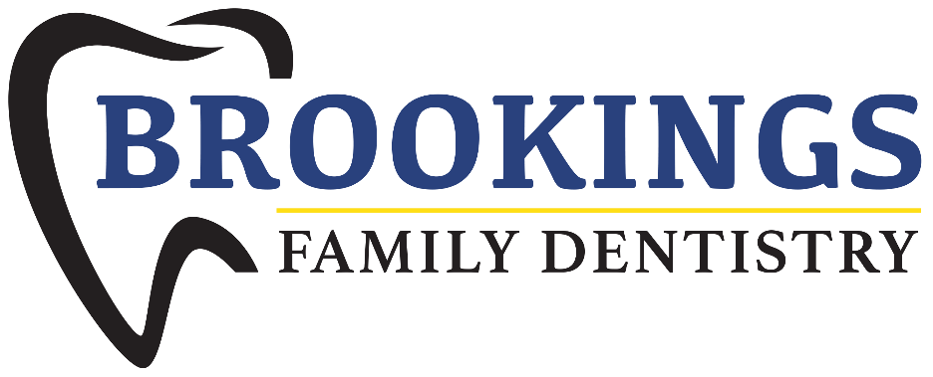

Dear New Patient,

Thank you for choosing Brookings Family Dentistry for your dental care needs.

Dr. Hilbrands and his staff look forward to introducing you to the benefits of quality dental care. We are dedicated to personal service and strive for dental excellence. Our goal is to help you achieve your best, and healthiest smile.

Our Staff is devoted to making your appointments as pleasant as possible. We take pride in being able to provide you with an excellent dental experience, designed to meet your unique dental needs.

We are sending you this welcome packet to fill out at your convenience, this will allow you time to have it filled out as needed, as well as save you time when you come for your appointment. Please complete the enclosed new patient form and bring it with you to your appointment, as well as your dental insurance card, and a list of any current medications you are taking. Feel free to contact us with any questions or concerns. We look forward to working with you!

Thank you,

Dr. Hilbrands and the Brookings Family Dentistry Team

